**Consumer Perceptions of Company Lexus’ Sustainability Goals and Initiatives**

A Project Completed for MKT 8610

7 August 2023

Taylar Grant

**Executive Summary**

This project was conducted to assess consumer perceptions of two of Lexus’ sustainability goals: (1) achieving carbon neutrality by 2050 and (2) introducing 10 new electric vehicles by 2025. The project sought to determine (a) the extent to which consumers find these goals important and achievable and the extent to which these goals impact consumer intentions to support Company X, (b) the relative perceived importance, achievability, and impact on intentions to support Company X of the goals, (c) whether perceptions of the goals differ across two market segments based on income and age, and (d) whether importance or achievability has a larger impact on consumer support. These objectives were accomplished with a consumer survey that included 99 respondents.

Noteworthy findings include:

* While consumers found both goals to be important, goal 2 was slightly more important than goal 1. Consumers indicated that achieving goal 2 would have a larger positive impact on their support of Lexus compared to achieving goal 1.
* Both sustainability goals were significantly more important and had a larger positive impact on intentions to support those who have a household income of $100,000 or more. There was some evidence that conservatives believed the goals were more achievable.
* For both goals, perceived importance of the goal had a larger positive impact on intentions to support Lexus than did perceived achievability.

These finding support the following managerial recommendations:

* Lexus should highlight goal 2 slightly more than goal 1 in marketing communications.
* These communications should be targeted, if possible, at consumers who tend to have a higher household income, specifically over $100,000.
* In developing and communicating sustainability goals, Lexus should focus on goals consumers perceive as important more so than goals consumers perceive as achievable.

**Introduction**

Sustainability has become an important factor for many consumers when it comes to making purchasing decisions. As a result, many businesses have ramped up their efforts to become more sustainable to appeal more to those customers. In the automobile industry, many companies have begun making the switch from gasoline powered vehicles to electric vehicles or EVs. One company that is best known for doing this is Tesla. Due to this increase in demand for electric vehicles, this research study was conducted to determine how important sustainability is when it comes to luxury vehicle purchasing, specifically from Lexus. While Lexus has many sustainability goals, this research focuses on two specific goals: (1) achieving carbon neutrality by 2050 and (2) introducing 10 new electric vehicles by 2025. The research focuses on these goals specifically because of the rise in demand for electric vehicles as well as calls for companies to improve their carbon emissions while producing their products.

There are four main objectives of this research. First, the research assesses whether

consumers find sustainability important overall. The second assesses whether consumers find the goals important and achievable and whether the goals have an impact on consumer intentions to support Company Lexus. Third, the research compares the relative impact on intentions purchase from and support Lexus of the two goals. Fourth, the research compares two market segments – those whose household income is $100,000 and over and those whose household income is under $100,000 -- that may react differently to achievability goals. Addressing these research objectives will provide managerially actionable insight into Lexus’ sustainability goals. Specifically, the findings can inform the types of sustainability goals Lexus develops, which goals are communicated to consumers, and which consumers should be targeted with these goals.

**Survey Design and Data Collection**

To address the research objectives, a survey was created and administered through the Qualtrics platform.[1] A trial version of the survey was pretested and based on feedback received, the survey was edited, resulting in the final survey provided in Appendix A. The survey contained 14 questions, including a mix of open-ended questions and scaled-response questions. A link to the survey was generated in Qualtrics and shared via email and Facebook, between Sunday, July 30th and Friday, August 4th.

After reading the introduction, respondents were presented with general warm-up questions regarding sustainability. After this brief warm-up the goals were presented. The order of the goals was randomized across respondents. They were asked to read the goals and indicate whether the goal resonated with them. From there, they reacted to three focal measures. All measures used five scale points and were anchored by “strongly disagree” and “strongly agree.” The first measure assessed the importance of the goal to respondents (“This goal is important to me personally”). The second measure assessed the perceived achievability of the goal (“This is a goal I believe car companies can achieve”). The third measure assessed the extent to which the goal would impact one’s intentions to purchase a vehicle from car companies (“I would purchase a vehicle from a company who has this goal.”). The fourth measure assessed the extent to which respondent would support a company with the goal (“I would support a car company with a statement similar to the sustainability goal mentioned.”) Respondents then repeated this process for the second goal. To conclude, respondents answered a series of demographic questions, including gender, age, and household income[2].

**Data Analysis**

**Description of Sample**

The sample consisted of 99 respondents. About half of the respondents had a household income of $100,000 and over and the other half had a household income of under $100,000. A little over half of the respondents in the sample were 45 and younger, with the rest being over the age of 45. About 83% of respondents identified as female, 15% as male and 1% as non-binary or a third gender. For comparison, this research focuses mainly on respondent’s household income and how it relates to how they answered the survey.

**Research Question 1: Do consumers find the sustainability goals important and achievable, and do the goals impact consumer intentions to support the company?**

To address this research question, we analyzed the importance, achievability, and intentions to support questions for both goals with one-sample t-tests to determine if the mean responses were significantly greater than the scale midpoint (3). Mean responses significantly greater than 3 indicate consumers find the goals to be important and achievable believe the goals would have a positive impact on intentions to support the company. As shown in the tables below, mean importance was significantly greater than 3 for goal 2 (M = 3.84) and for goal 1 (M =3.37). Mean achievability was significantly greater than 3 for goal 1 (M = 3.56) and goal 2 (M =3.85). Mean purchase intent was significantly greater than 3 for goal 1 (M=3.74) and goal 2 (M=3.86). Mean impact was significantly greater than 3 for goal 1 (M = 3.80) and goal 2 (M = 3.85). Thus, achievement of both goals would positively impact consumer intentions to support Lexus. While goal 1 is important to consumers, consumers believe that goal 2 is just slightly more important than goal 1.

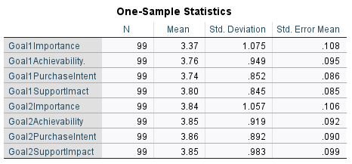

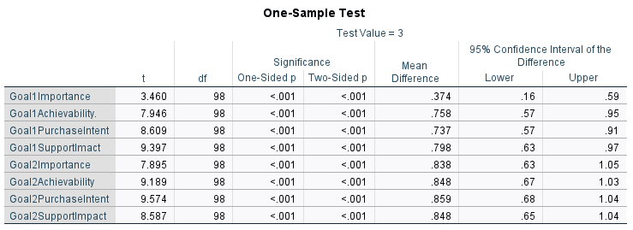

**Research Question 2: Which goal do consumers believe is more important, more achievable, and more positively impacts consumer intentions to support Lexus?**

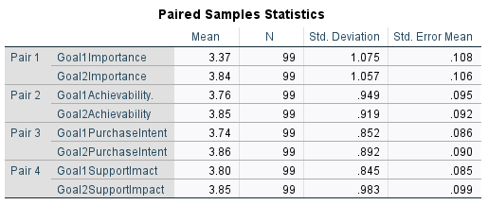 To address this research question, we compared mean importance, achievability, purchase intent and intentions to support the two goals using paired-samples t-tests via IBM SPSS. As shown in the tables below, respondents found goal 2 (M = 3.84) more important than goal 1 (M =3.37). Respondents also felt goal 2 (M = 3.85) was slightly more achievable than goal 1 (M = 3.76). Similarly, goal 2 (M = 3.86) had a larger impact on intentions to purchase from Lexus than did goal 1 (M =3.74). Lastly, respondents felt that they would support a company with goal 2 (M=3.85) more than a company with goal 1 (M=3.80).

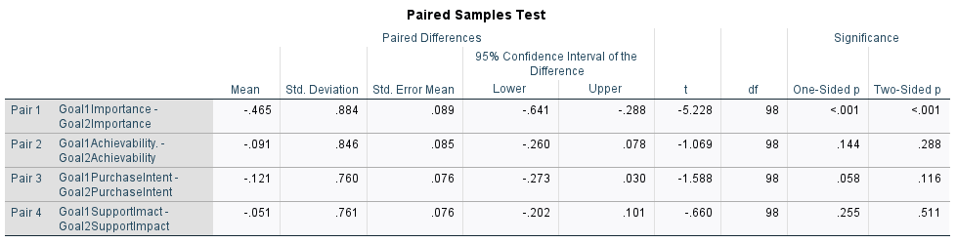

**Research Question 3: Does importance, achievability, and impact on intentions to support differ across market segments? Specifically, those who make $100,000 and over and those who make under $100,000.**

We examined household income as a segmentation base by comparing goal importance, achievability, and impact on intentions to support across respondents who had a household income of $100,000 and over and those who have a household income of under $100,000, using independent samples t-tests. The results for each goal are provided below. For goal 1, respondents with a household income of $100,000 and over found the goal slightly more important (MLess100K = 3.32, M100K+ = 3.45). Those with a household income of over $100K were also slightly more likely to believe Lexus would achieve the goal (M100K+= 3.83, MLess100K = 3.74). The groups did not differ in their beliefs that the goal would impact their intentions to support the company, but those with a household income of $100k and over had a higher purchase intent (MLess100K 3.66, M100K+ = 4.02). For goal 2, respondents making $100K and over found the goal significantly more important (M100K+= 3.95, MLess100K= 3.74) and more likely to positively impact their intentions to support the company (MLess100K= 3.81, M100K+ = 3.98). The groups did not significantly differ in their beliefs that Company X would achieve goal 2 (MLess100K = 3.89, M100K+ = 3.93).

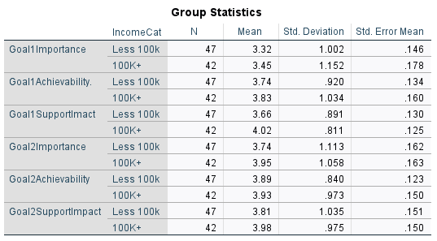

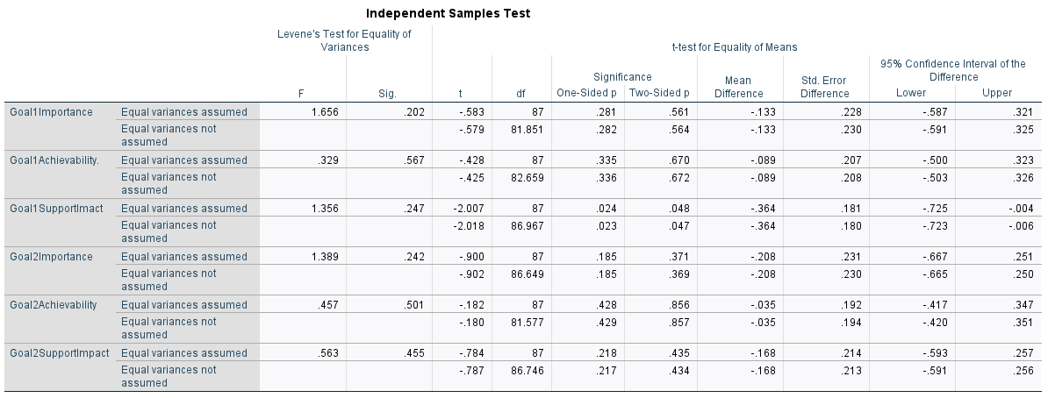

**Research Question 4: Does importance or achievability have a larger impact on Purchase intent?**

To determine whether goal importance or achievability has a larger impact on purchase intentions, we conducted a multiple regression for each goal. Purchase intent was the dependent variable, while beliefs that the goal was important and achievable were the independent variables.

For goal 1, as the results below indicate, the model explained 43.2% of the variance in intentions to purchase. Beliefs about both goal importance (b = .37) and goal achievability (b = .25) had positive effects on intentions to Purchase. importance had a larger effect as indicated by the standardized coefficient (standardized b = .47).

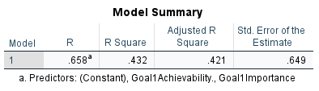

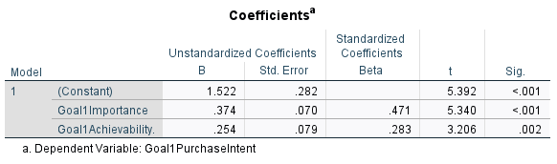

For goal 2, as the results below indicate, the model explained 57.4% of the variance in intentions to support. Beliefs about both goal importance (b = .50) and goal achievability (b = .26) had positive effects on intentions to support. Importance had a significantly larger effect as indicated by the standardized coefficient (standardized b = .59).

These results indicate that, while both importance and achievability positively impact intentions to support, importance has a larger impact, and a significantly larger impact for the second goal.

**Research Question 5: Does importance or achievability have a larger impact on support the company?**

To determine whether goal importance or achievability has a larger impact on whether a consumer supports Lexus, we conducted a multiple regression for each goal. Impact on support was the dependent variable, while beliefs that the goal was important and achievable were the independent variables.

For goal 1, as the results below indicate, the model explained 50.3% of the variance in intentions to support. Beliefs about both goal importance (b = .34) and goal achievability (b = .35) had positive effects on intentions to support. Importance had a slightly larger effect as indicated by the standardized coefficient (standardized b = .43).

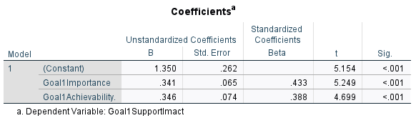

For goal 2, as the results below indicate, the model explained 57.6% of the variance in intentions to support. Beliefs about both goal importance (b = .55) and goal achievability (b = .29) had positive effects on intentions to support. Importance had a significantly larger effect as indicated by the standardized coefficient (standardized b = .59).

**Conclusions**

Our findings have various managerial implications. In terms of the perceived importance and achievability of the sustainability goals and their impact on intentions to support Lexus (see results for Research Question 1), respondents felt that goal 2 was slightly more important than goal one and both goals, if achieved, would positively impact their intentions to support the company, with goal 2 still being more important across the board. Overall, these findings suggest that both goals can have positive implications for Lexus, but more focus should be put on Lexus’ second sustainability goal, which talked about introducing 10 new electric vehicles by 2025.

Regarding preference for one goal over the other (see results for Research Question 2), respondents indicate a clear preference for goal 2 in terms of importance, achievability, and intentions to support Lexus. If Lexus should focus on promoting and highlighting their second goal of introducing 10 new EVs by 2025 to continue to gain support from consumers.

Compared to respondents with a household income of less than $100,000, respondents with a household income of over $100K found both goals to be more important and felt goal 2 would more positively impact both their purchase intent and their support of Lexus. Based on these findings, it is recommended that, if possible, the sustainability goals, especially goal 2 (10 new electric vehicles by 2025) be targeted at those with a household income of $100K and over.

Finally, for both goals, both importance and achievability were positively related to intentions to support Lexus. However, importance was more strongly related. Consequently, we recommend that in developing and promoting sustainability goals, Lexus focus on goals consumers believe are important more so than goals consumers believe are achievable and in turn would give their support and even purchase from the brand.

**Limitations**

In considering the findings of this research, we note the following limitations. First, there was difficulty obtaining a complete 50/50 sample of each group, in this case household income. A better approach would have been to have just have a household income question with two options: (1) $100,000 and over, and (2) under $100,000 instead of having multiple income options to choose from. It would have made data collection and analyzation in SPSS quicker and more efficient.

Second, there was a lot of responses from those that identify as female. Over 80% of respondents were female with the rest identifying as male or non-binary/ a third gender. With the link being sent out randomly, there was no way to completely check which gender was completing the survey until after the responses had been recorded. Despite not using it as a measure of comparison, putting a limit on how many people of one gender can respond would be one way to collect the data differently.

Finally, the survey was completed as a disguised survey. This means that respondents were only aware of who was completing the research (in this case Clemson University MS in Marketing students) and not who the data was being collected for (Lexus). A better approach would have been to make it a little bit more obvious who the data was being collected for in order to get responses that are more focused towards Lexus instead of the overall car industry.

At the end of the survey, an open-ended, not required question was asked. The question was if the respondents had any questions, comments or concerns. While most opted to skip the question, some left comments such as how Tesla should have been added in the lineup for Q3 (reference the appendix). Another comment stated that a definition for sustainability should have been added as well. Adjustments should be made to include these factors in the future.

**Appendix A**

**Sustainability Project**1

**Start of Block: Introduction**

Introduction Thank you for participating in this survey. With the rise of sustainability efforts in a wide variety of industries, we are trying to determine whether or not consumers find the sustainability goals of luxury car companies important, as well as a factor into whether or not they purchase from certain companies. This survey will be completely anonymous and should take approximately 5 minutes to complete.

**End of Block: Introduction**

**Start of Block: Warm Up**

|  |
| --- |
|  |

Q1 How important is sustainability to you when choosing a vehicle?

|  |  |  |  |  |  |  |  |  |
| --- | --- | --- | --- | --- | --- | --- | --- | --- |
|  | 1 (1) | 2 (2) | 3 (3) | 4 (4) | 5 (5) | 6 (6) | 7 (7) |  |
| Not very important |  |  |  |  |  |  |  | Very important |

|  |
| --- |
|  |

Q2 How likely are you to purchase a car from a company with public sustainability goals?

* Extremely unlikely (1)
* Somewhat unlikely (2)
* Neither likely nor unlikely (3)
* Somewhat likely (4)
* Extremely likely (5)

|  |
| --- |
|  |

Q3 Which luxury car company do you believe is the most sustainable?

* BMW (1)
* Acura (2)
* Lexus (3)
* Audi (4)
* Mercedes (5)

**End of Block: Warm Up**

**Start of Block: Goal 1**

Q4 Please read this statement carefully:   
  
"As part of our ‘Electrified’ vision, we plan to introduce 10 new electrified vehicles by 2025, and aim to only be offering Hybrid, PHEV and BEV luxury vehicles in Australia by 2030."

|  |
| --- |
|  |

Q5 How much did the previous statement resonate with you?

* Not at all (1)
* A little (2)
* A moderate amount (3)
* A lot (4)
* A great deal (5)

|  |  |
| --- | --- |
| Page Break |  |

|  |
| --- |
|  |

Q6 Indicate how much you agree or disagree with the following statements about the previous sustainability goal?

|  |  |  |  |  |  |
| --- | --- | --- | --- | --- | --- |
|  | Strongly disagree (1) | Somewhat disagree (2) | Neither agree nor disagree (3) | Somewhat agree (4) | Strongly agree (5) |
| This goal is important to me personally. (Q6_1) |  |  |  |  |  |
| I believe that this goal is achievable by car companies. (Q6_2) |  |  |  |  |  |
| I would purchase a vehicle from a company who has this goal. (Q6_3) |  |  |  |  |  |
| I would support a car company with a statement similar to the sustainability goal mentioned. (Q6_4) |  |  |  |  |  |

**End of Block: Goal 1**

**Start of Block: Goal 2**

Q7 Please read the statement carefully:  
  
"By 2050, we aim to achieve carbon neutrality throughout the lifecycle of our entire model line-up – from the manufacturing of materials, parts and vehicles, to vehicle logistics, to the final disposal and recycling of older vehicles."

|  |
| --- |
|  |

Q8 How much did the previous statement resonate with you?

* Not at all (1)
* A little (2)
* A moderate amount (3)
* A lot (4)
* A great deal (5)

|  |
| --- |
|  |

Q9 Indicate how much you agree or disagree with the following statements about this sustainability goal?

|  |  |  |  |  |  |
| --- | --- | --- | --- | --- | --- |
|  | Strongly disagree (1) | Somewhat disagree (2) | Neither agree nor disagree (3) | Somewhat agree (4) | Strongly agree (5) |
| This goal is important to me personally. (Q9_1) |  |  |  |  |  |
| I believe that this goal is achievable by car companies. (Q9_2) |  |  |  |  |  |
| I would purchase a vehicle from a company who has this goal. (Q9_3) |  |  |  |  |  |
| I would support a car company with a statement similar to the sustainability goal mentioned. (Q9_4) |  |  |  |  |  |

**End of Block: Goal 2**

**Start of Block: Overall**

|  |
| --- |
|  |

Q10 If a car company achieves these goals, how would it impact your support of the company?

|  |  |  |  |  |  |  |
| --- | --- | --- | --- | --- | --- | --- |
|  | 1 (1) | 2 (2) | 3 (3) | 4 (4) | 5 (5) |  |
| I'd be much less likely to support |  |  |  |  |  | I'd be much more likely to support |

**End of Block: Overall**

**Start of Block: Demographics**

|  |
| --- |
|  |

Q11 What is your age group?

* under 18 (1)
* 18 - 24 (2)
* 25 - 34 (3)
* 35 - 44 (4)
* 45 - 54 (5)
* 55 - 64 (6)
* 65 - 74 (7)
* 75 - 84 (8)
* 85 or older (9)

|  |
| --- |
|  |

Q12 what is your gender?

* Male (1)
* Female (2)
* Non-binary / third gender (3)
* Prefer not to say (4)

|  |
| --- |
|  |

Q13 What is your household income?

* under $29,000 (1)
* $30,000- $49,000 (2)
* $50,000- $74,000 (3)
* $75,000- $99,000 (4)
* over $100,000 (5)
* Prefer not to say (6)

**End of Block: Demographics**

**Start of Block: Outro**

Q14 Thank you for your participation. Do you have any comments, questions or concerns?

________________________________________________________________

**End of Block: Outro**

1. Qualtrics.com
2. Copy of survey provided in Appendix A